Debian及Rstudio升级

目录
- 1 Debian升级
- 2 zhu=
- 3 升级R
- 4 安装Rstudio
- 5 R Tidyverse install package error
- 6 remove / uninstall R packages
- 7 Install R Rstudio for Debian12 (2024.3)
  - 7.1 How to install R Rstudio on Linux Debian 11.3 (youTube)
  - 7.2 install rstudio on debian 12 (solution from checking web rstudio community )
  - 7.3 run rstudio fr xterm
- 8 install rstudio on Win 10/11

Debian升级
升级所有现有的软件包。 $ sudo apt upgrade
更新可用的软件包。 $ sudo apt update
1、通过运行以下命令确认 Debian 10 代号。Debian 10 的代号为 buster。 $ lsb_release -a
你的输出应该是： No LSB modules are available. Distributor ID: Debian Description: Debian GNU/Linux 10 (buster) Release: 10 Codename: buster
3、将原始配置文件备份到您的主目录。 $ sudo cp /etc/apt/sources.list ~/sources.bak $ sudo cp -r /etc/apt/sources.list.d/ ~/sources.list.d.bak
4、在您喜欢的编辑器中打开 /etc/apt/sources.list。 $ sudo nano /etc/apt/sources.list
5、当前条目应如下所示：(ctrl+x) deb http://deb.debian.org/debian/ buster main deb-src http://deb.debian.org/debian/ buster main
deb http://security.debian.org/debian-security buster/updates main deb-src http://security.debian.org/debian-security buster/updates main
- buster-updates, previously known as 'volatile'
deb http://deb.debian.org/debian/ buster-updates main deb-src http://deb.debian.org/debian/ buster-updates main
将这些行替换为：
deb http://deb.debian.org/debian bullseye main deb-src http://deb.debian.org/debian bullseye main
deb http://security.debian.org/ bullseye-security main deb-src http://security.debian.org/ bullseye-security main
deb http://deb.debian.org/debian bullseye-updates main deb-src http://deb.debian.org/debian bullseye-updates main
7、再次更新软件包列表。如果您正确地进行了更改，则在更新过程中不会显示任何错误。
$ sudo apt update
8、执行系统升级。使用 –without-new-pkgs 标志来避免删除您打算保留在服务器上的软件包。
$ sudo apt upgrade --without-new-pkgs
E: Unmet dependencies. Try 'apt --fix-broken install' with no packages (or specify a solution).
sudo apt --fix-broken install sudo apt-get update sudo apt-get upgrade
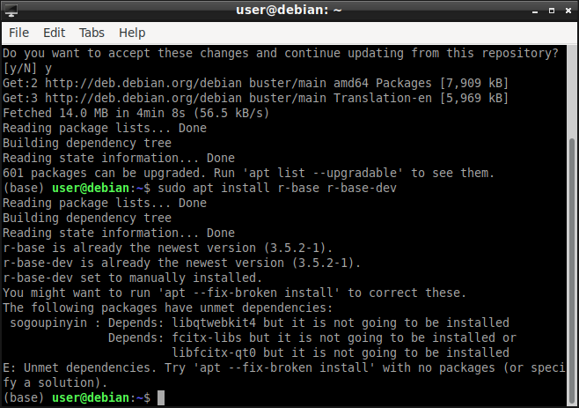
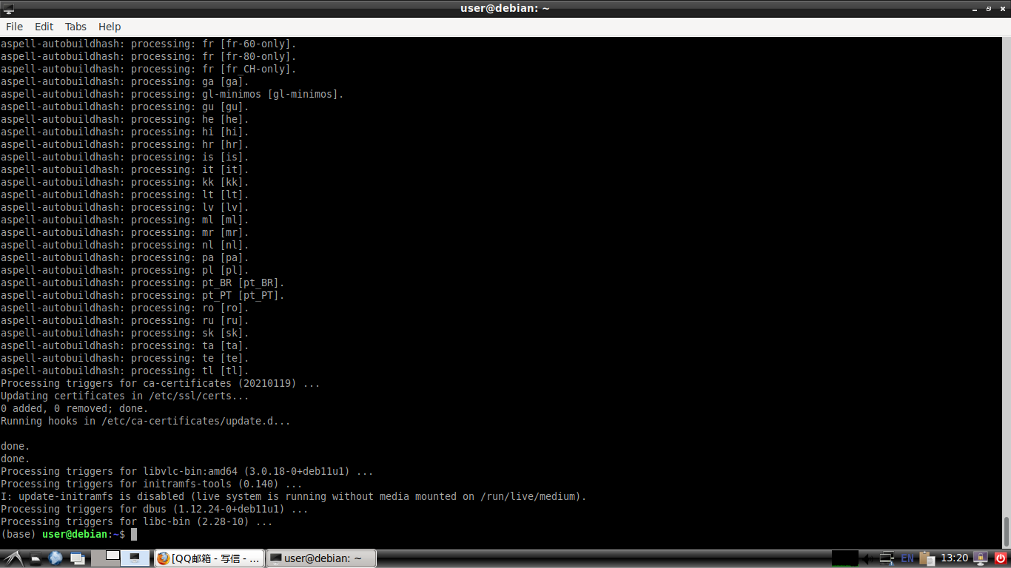
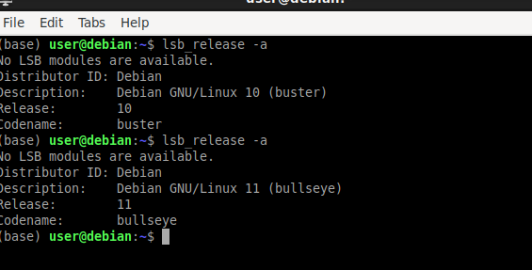

zhu=
Debian内核可能会变得过时，因此需要升级内核来提高安全性和性能。下面的命令将升级Debian内核到最新版本： sudo apt-get update sudo apt-get install linux-image-$(uname -r|sed 's,[^-]*-[^-]*-,,') linux-headers-$(uname -r|sed 's,[^-]*-[^-]*-,,')
下面的命令将升级Debian所有软件包到最新版本：
sudo apt-get update sudo apt-get upgrade sudo apt-get dist-upgrade
Debian版本号格式为major.minor.patch，例如10.9.0。我们可以使用以下命令将Debian从一个版本升级到另一个版本：
sudo sed -i 's/buster/bullseye/g' /etc/apt/sources.list sudo apt-get update sudo apt-get upgrade sudo apt-get dist-upgrade
如果您使用的是Debian 11，可以通过以下命令将其升级到Debian 12：
sudo sed -i 's/bullseye/bookworm/g' /etc/apt/sources.list sudo apt-get update sudo apt-get dist-upgrade

升级R
sudo apt-get update
sudo apt-get install r-base r-base-dev
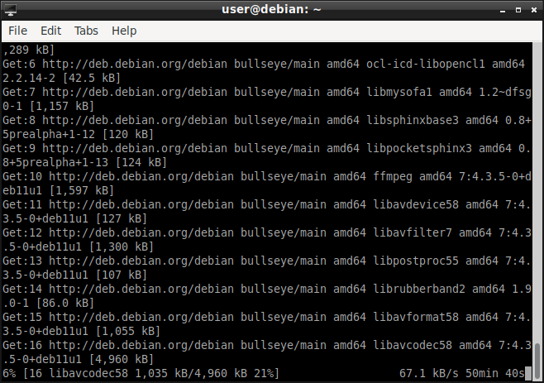

R --version
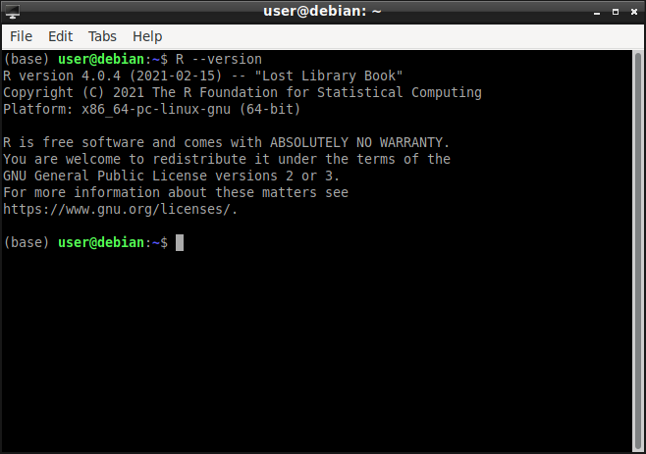
安装个gdebi，方便安装Rstudio servcer的deb包
sudo apt -y install gdebi-core
获取Rstudio Server 1.4.1106的deb包
wget https://download2.rstudio.org/server/xenial/amd64/rstudio-server-1.4.1106-amd64.deb
这个下载下来就在当前目录了
使用gdbi安装Rstudio Server 1.4.1106
sudo gdebi rstudio-server-1.4.1106-amd64.deb
sudo rstudio-server restart sudo rstudio-server status # 查看Rstudio状态
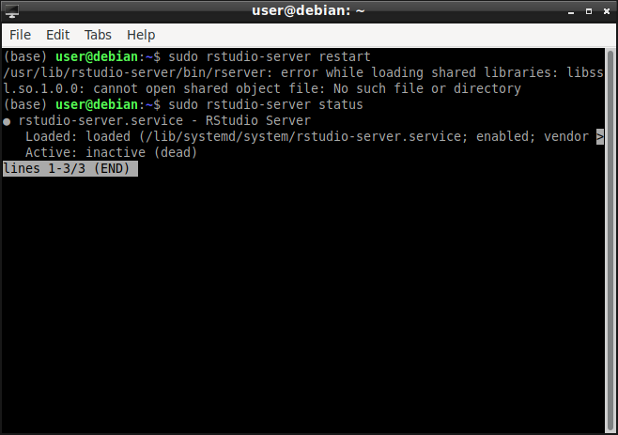
baocuo
wget https://www.openssl.org/source/openssl-1.1.1v.tag.gz

安装Rstudio
https://posit.co/download/rstudio-desktop/
sudo dpkg -i rstudio-2023.06.2-561-amd64.deb

R Tidyverse install package error
remove.packages("Dplyr") remove.packages("tidyr") remove.packages("stringr") remove.packages("tibble")
I got this error when installing at first:
ERROR: dependencies ‘googledrive’, ‘googlesheets4’, ‘httr’, ‘ragg’, ‘rvest’, ‘xml2’ are not available for package ‘tidyverse’
debian10 I've just tried this in Debian 10:
sudo apt-get install r-cran-tidyverse
and verified with:
library(tidyverse)
debian 11&12 then ran this and tried again and ok
sudo apt-get install libxml2-dev libssl-dev libcurl4-openssl-dev libfontconfig1-dev libharfbuzz-dev libfribidi-dev libfreetype6-dev libpng-dev libtiff5-dev libjpeg-dev

remove / uninstall R packages
- 先查看现状
mypackages <- installed.packages()[,c('Package','Version','LibPath')] %>% as.data.frame()
write.csv(mypackages, "~/temp/mypackages.csv")
- 卸载 R包 (建议在 packages 里 右面 勾选 X )
remove.packages(c("RSQLite","yeastRNASeq","yyplot"), lib = .libPaths()[1])
remove.packages(c("IRdisplay","IRkernel"), lib = .libPaths()[2])

- 再查看现状
mypackages <- installed.packages()[,c('Package','Version','LibPath')] %>% as.data.frame()
write.csv(mypackages, "~/temp/mypackages.csv")

debian 12 R bao sessionInfo()
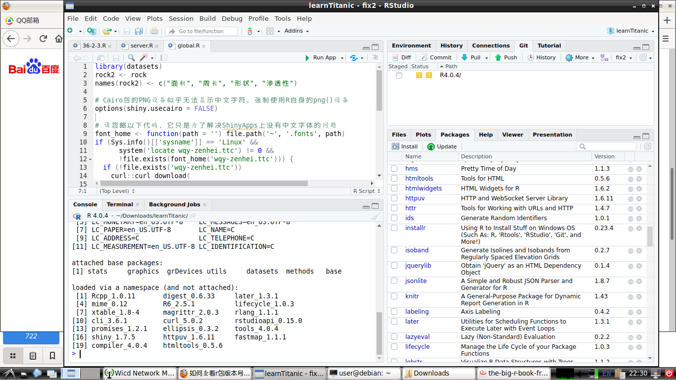
debian 10 R bao sessionInfo()
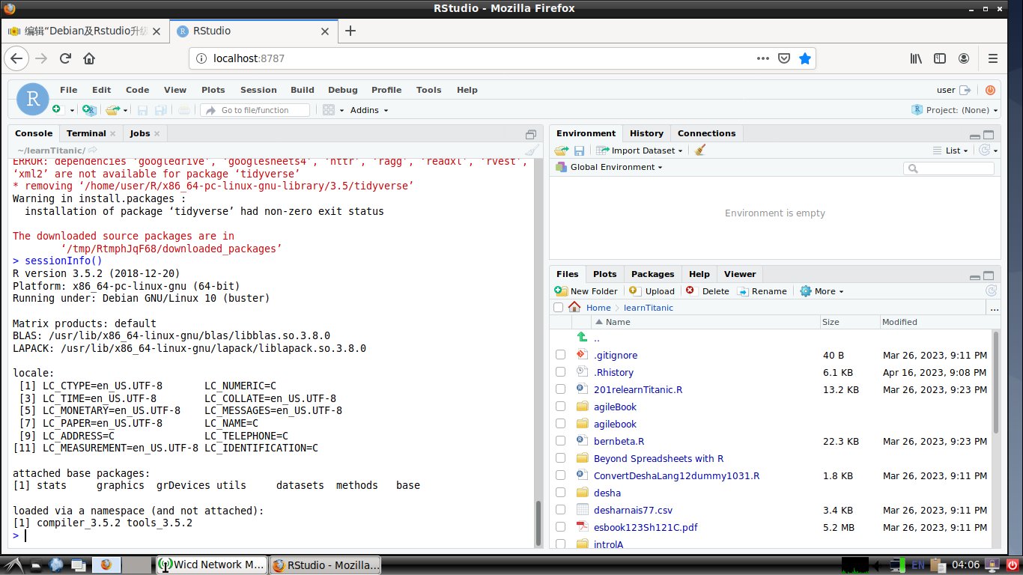

Install R Rstudio for Debian12 (2024.3)

How to install R Rstudio on Linux Debian 11.3 (youTube)
$ lsb_release -a # check debian version
$ apt update #sudo apt update (to run from root super user)
$ apt install r-base #sudo apt install r-base
$ R --version # check if install R ok , get 4.2.2
$ sudo -i R # to try out the console mode R (optional)
$ apt install gdebi-core #sudo apt....
$ sudo apt install wget (optional , only if wget not installed)
$ wget https://......
- tried latest rstudio-2023.12.1-402-amd64.deb but cannot install, say
  - package uninstallable
  - dependency is not satisfiable: libssl1......

install rstudio on debian 12 (solution from checking web rstudio community )
wget http://security.debian.org/debian-security/pool/updates/main/o/openssl/libssl1.1_1.1.1n-0+deb10u6_amd64.deb
dpkg -i libssl1.1_1.1.1n-0+deb10u6_amd64.deb
wget https://download1.rstudio.org/electron/focal/amd64/rstudio-2023.09.0-463-amd64.deb
gdebi rstudio-2023.09.0-463-amd64.deb
cannot complete, "Need to be root to install packages , add sudo in front to run as super user
- Result
  - R-base 4.2.2 (2022.11)
  - Rstudio 2023.9.0 Build 463
- Reference
  - "Can't install rstudio on debian 12" from community.rstudio.com
  - 2023-10-11

run rstudio fr xterm
$ rstudio

install rstudio on Win 10/11
---===<<< END >>>===---

